Assessment of the impact of water level management on flood risk

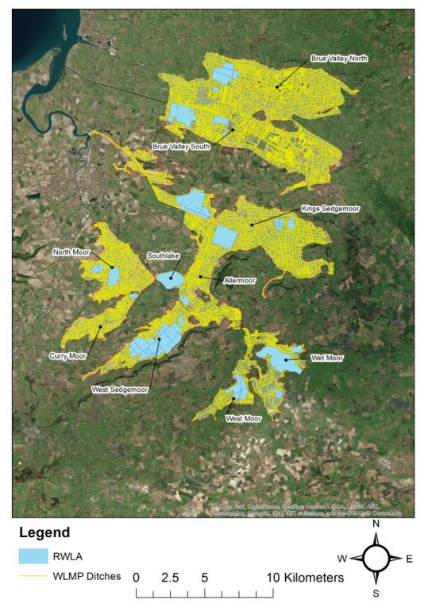
Introduction

The Somerset Drainage Boards Consortium has undertaken an assessment of the role of water level management in the severity of flooding in Somerset. This leaflet provides a summary of the main findings of the assessment and a full copy of the report can be downloaded from the SDBC website <LINK>

Summary

Understandable concerns have been raised that the maintenance of seasonal water levels can increase the severity of flooding by occupying storage capacity in ditches. Therefore, the Somerset Drainage Boards Consortium has assessed the effects of water level management on flooding in order to address these concerns.

Seasonal water levels are managed in ditches to minimise the impacts of flooding and provide water for agricultural and nature conservation purposes. Water levels are maintained in summer to meet the needs of farming. In winter, water levels are generally lowered to enhance drainage, but in a subset of ditches they are maintained in winter to sustain wetland habitats and create conditions for over-wintering and breeding birds. These wetland schemes are known as raised water level areas.

Methods

Ditch and soil water storage capacities were calculated using the best available evidence and observations collected from Somerset and other low lying areas. The storage occupied by seasonal water level management practices was also calculated and assessed in relation to the maximum flood volumes and levels experienced during winter 2013/14, as well as the volumes and levels of less extreme flood events.
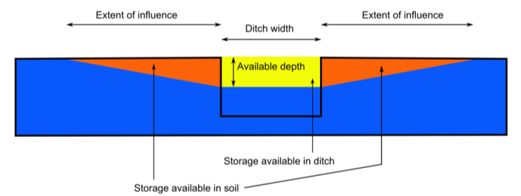
Illustration of the calculation of ditch and soil storage. Yellow shading indicates the available storage capacity in the ditch and red shading indicates the available storage capacity in the soil. The blue shading indicates the water level in the ditch and saturated soil
Results

Assessments of the impact of water level management on flooding were made for all moors that experienced severe flooding in winter 2013-14.
- Raised water level area schemes cover 2529 ha, or 4.6% of the Parrett and Axe Brue Drainage Boards area.
- The volume of water required to maintain raised water level areas in winter is equivalent to just 0.6% of maximum flood volume during winter 2013/14, or an increase in flood level of between 0.03 and 1.2 cm.
- The volume of water required for agricultural water levels in summer is equivalent to 3.6% of the maximum flood volume during winter 2013/14, or an increase in flood level of between 2.1 and 6.2 cm.
- For less severe flooding, where the flood level reaches the lowest road in an area, the volume of water required to maintain raised water level areas in winter is equivalent to 2.5% of the flood volume, or an increase in flood level of between 0.08 and 2.3 cm. In summer, this increases to 10.1% of the flood volume, or an increase in flood level of between 2.7 and 6.6 cm.
- For moors that depend on pumping stations for drainage, the volume of water used to maintain raised water level areas in winter would take between 0.05 hours and 5.47 hours (average 3.5 hours) to evacuate using the permanent pumping station capacity. This increases to between 7.1 and 25.1 hours (average 15.2 hours) to pump the volume of water required for agricultural water levels in summer.
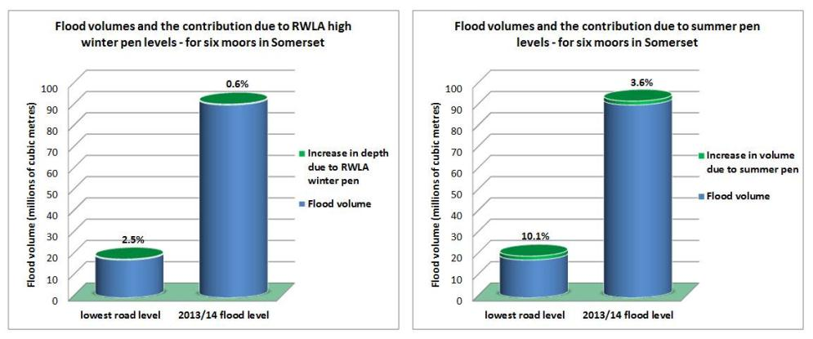
- The maximum storage capacity of ditches and soils is equivalent to just 9.5% of the total rainfall that fell directly within the study area during December, January and February 2013-14.
Conclusion

The assessment finds that the volume of water maintained within ditches, and corresponding reduction in flood storage capacity, represents a very small fraction of the volume of flood water stored on the moors during major flood events. Expressed both as a proportion of the maximum flood volume or change in flood level, the calculations indicate that winter raised water level areas have only a very minor impact on large flood events. Water levels for agriculture in summer occupy larger volumes, but these are still small compared to volumes of water stored on the moors during major flood events.

