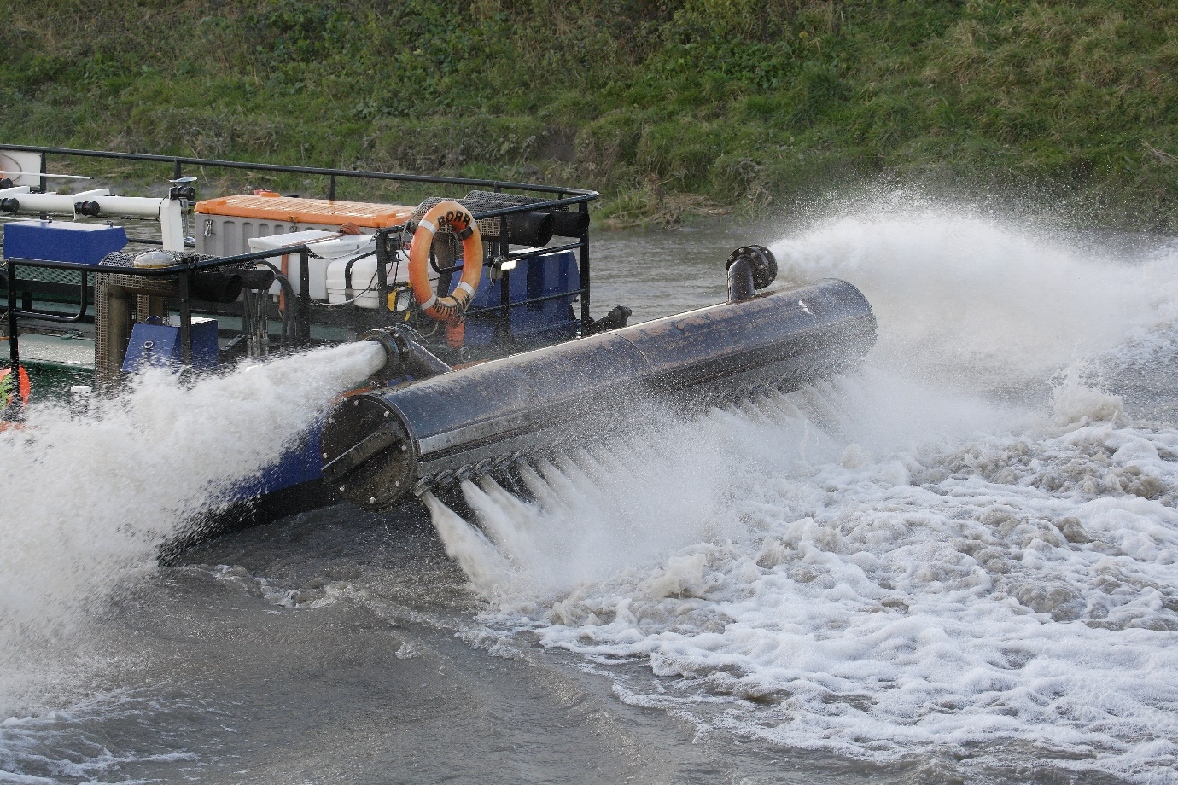
Another Water Injection Dredging (WID) campaign was carried out on the Parrett in January. Water Injection Dredging uses a jet bar moved over the surface of the channel bed while large volumes of water are directed at low pressure into the sediment layer. The density of the sediment surface layer is lowered until it achieves fluid behaviour. The fluidized sediment layer is then transported horizontally in the lower part of the water column away from the dredged areas by river flow during outgoing tides. The fluidized sediment eventually enters lower estuary where it mixes with extremely high background turbidity conditions. General practice is to start dredging at the downstream extent of the site, which increases channel gradients and facilitate mobilisation and transportation of the fluidized sediment downstream.
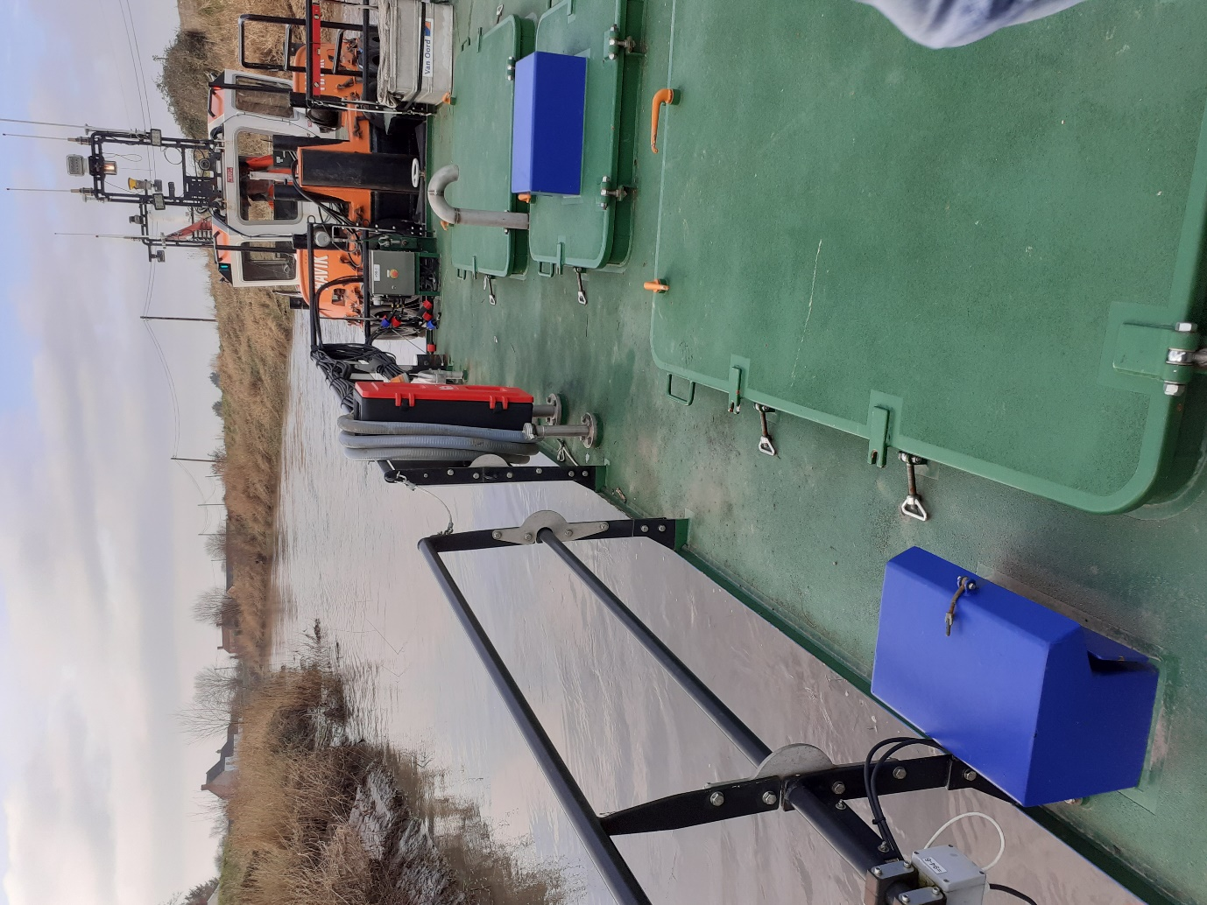
Our Term Contractor, Van Oord used a new vessel this year specifically designed for dredging upper estuary systems like the River Parrett. In previous years, Water Injection Dredging was undertaken using a self-propelled vessel called the ‘Borr’ (above), which had an injector bar that was orientated towards the channel bed. In 2022 an alternative WID configuration of ‘Baldr’ and ‘Havik’ (below) has been deployed. The Baldr has the same WID capacity as the Borr, but is propelled by a separate vessel called Havik. The Baldr can operate in shallower water and smaller channel cross sections, thereby greatly extending the potential for dredging under different tidal conditions. Furthermore, the injector bar angle of the Baldr can be adjusted allowing greater flexibility and precision in dredging, especially in the channel margins. Dredging over an 18-day period in Jan 2022, funded by Somerset Rivers Authority, removed around 20,000m³ of consolidated silt from a 4km reach of the river, increasing flow capacity and reducing flood risk.

